Chapter 8

Exercise Solutions

Ex 8.1
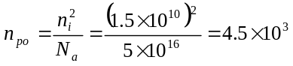cm
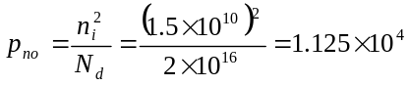cm
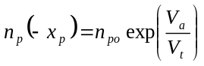
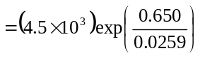
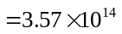cm
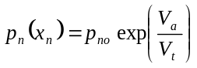
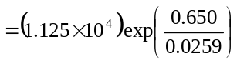
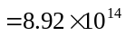cm
We have that
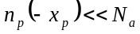 and 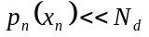
so low injection applies.
_______________________________________

Ex 8.2
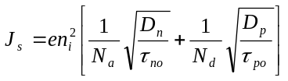
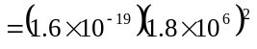
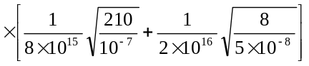
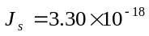A/cm
_______________________________________

Ex 8.3
We find
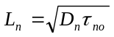
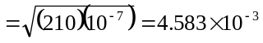cm
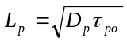
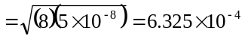cm

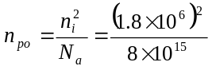
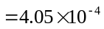cm
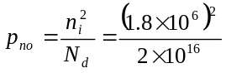
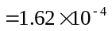cm
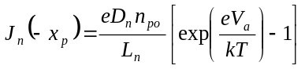
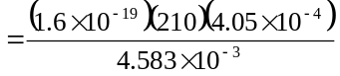
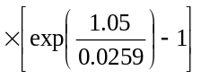
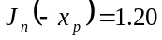A/cm
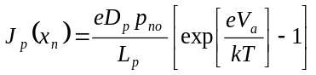
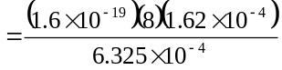
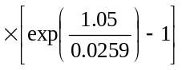
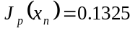A/cm
The total current density is:
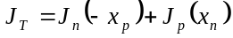
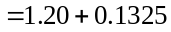
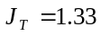A/cm
_______________________________________

Ex 8.4
In the n-region, for 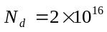cm,
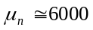cm/V-s
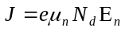
or
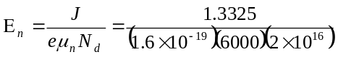
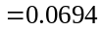V/cm
In the p-region, for 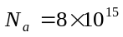cm,
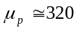cm/V-cm
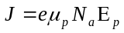
or

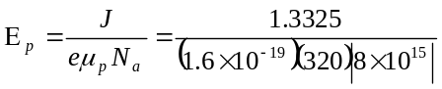
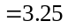V/cm
_______________________________________

Ex 8.5
From Example 8.5, we have
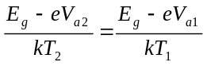
Let 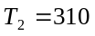K, 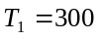K, 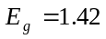eV,
and 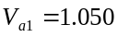V.
Then
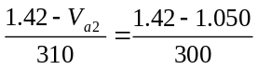
which yields
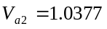V
so V
or 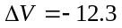mV per 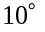C increase in
temperature.
_______________________________________

Ex 8.6
- 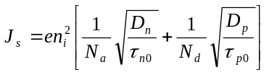
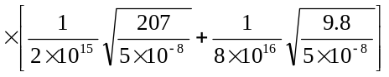
or 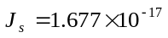A/cm
- 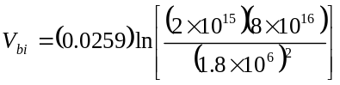
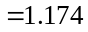V
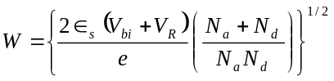
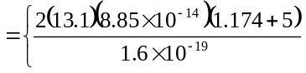
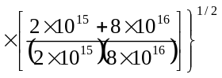
or 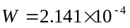cm

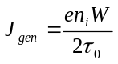
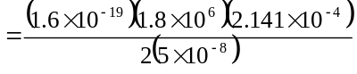
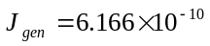A/cm
- 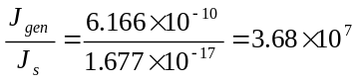
_______________________________________

Ex 8.7
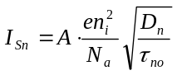
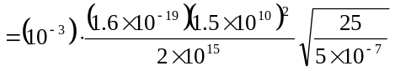
or
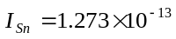A
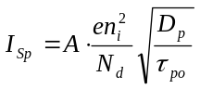
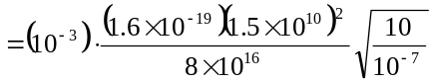
or
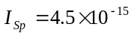A
Then
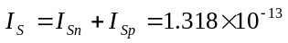A
- 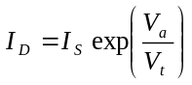
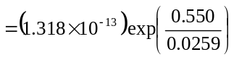
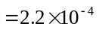A
- 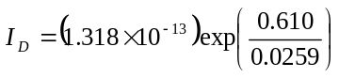
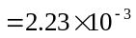A
Now
- 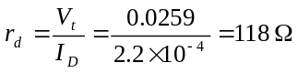
- 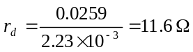

We find
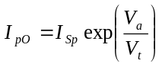, 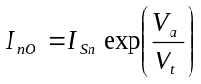
Then
- 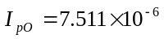A; 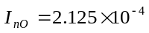A
- 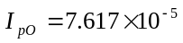A; 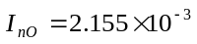A

We find
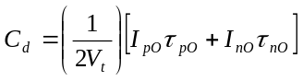
So
- 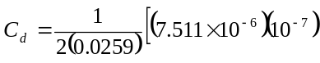
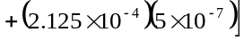
or 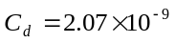F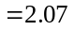nF
- 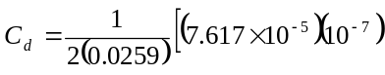
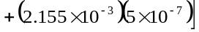
or 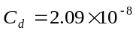F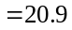nF
_______________________________________

Test Your Understanding Solutions

TYU 8.1
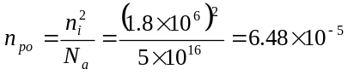cm
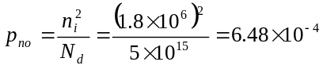cm
For 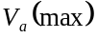,
so that
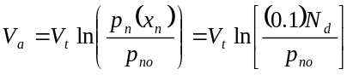
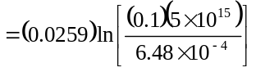
or 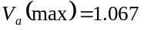V
_______________________________________

TYU 8.2
- 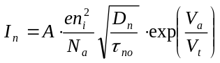
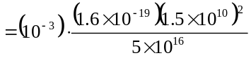
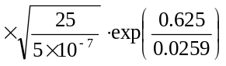
or 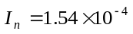A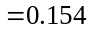mA
- 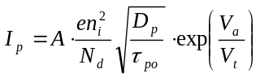
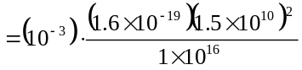
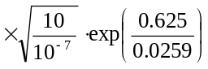
or 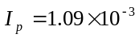A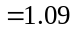mA
- 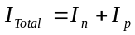
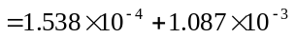
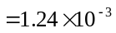A
or 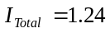mA
_______________________________________

TYU 8.3
From TYU 8.2, 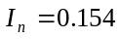mA
Now
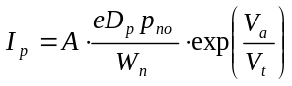
We find
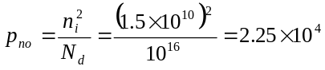cm
Then
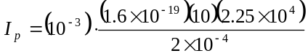
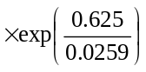
or 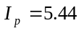mA
_______________________________________

TYU 8.4
- 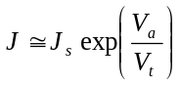
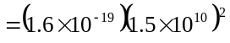
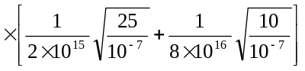
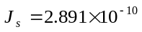A/cm
Then 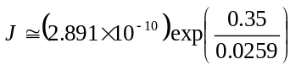
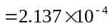A/cm
- 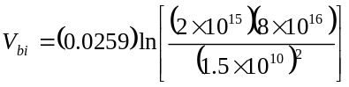
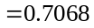V
We find
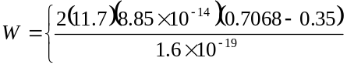
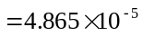cm
Then
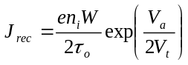
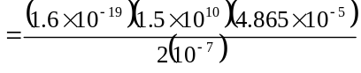
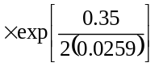
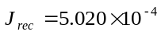A/cm
- 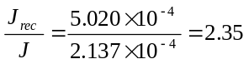
_______________________________________

TYU 8.5
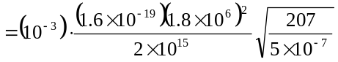
or 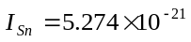A

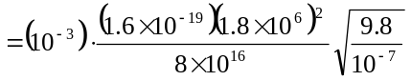
or 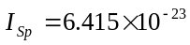A
So 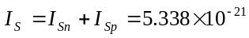A
- 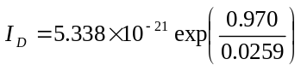
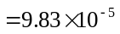A
- 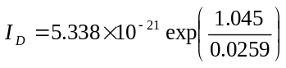
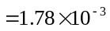A
Now
- 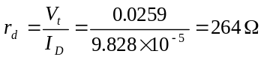
- 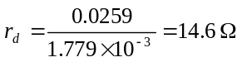
We have
,
We find
- 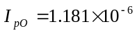A; 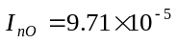A
- 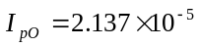A; 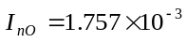A
Now
So
- 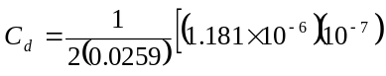
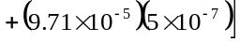
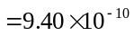F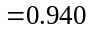nF
- 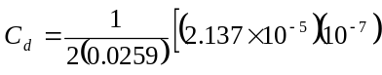
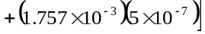
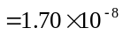F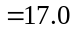nF
_______________________________________

TYU 8.6
From Figure 5.3, for 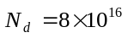cm,
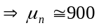cm/V-s
For 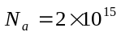cm,
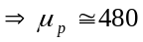cm/V-s
In the n-region,
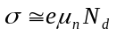
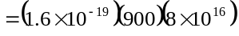
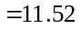(-cm)
Then
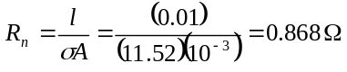
In the p-region,
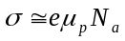
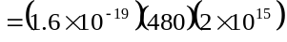
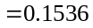(-cm)
Then
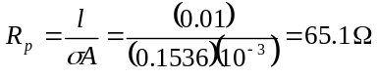
The total resistance is
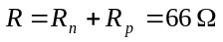
_______________________________________

TYU 8.7
- 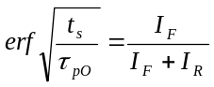
Now
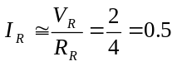mA
So
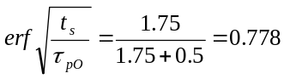
From Appendix G, 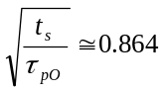
So that
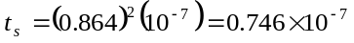s

- 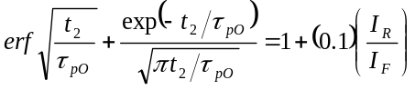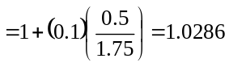
By trial and error
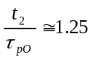
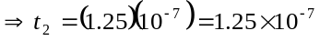s
_______________________________________

